 | GEETA ENGINEERING COLLEGE, NAULTHA, PANIPAT |  |  | LABORATORY MANUAL
EXPERIMENT TITLE: Write a program to plot the following function a) impulse function b)unit step c)unit ramp d)expnentional e)sinusoidal |  |  |  | EXPERIMENT NO: GEC-LM- EC-311LA -01
ISSUE NO : 001 | ISSUE DATE | 19-12-2013 | REV NO: 003 | REV DATE | 14-01-2021
DEPARTMENT: | ECE | LABORATORY: | DSP | SEMESTER: | 5TH

AIM: Write a program to plot the following function a) impulse function b)unit step c)unit ramp d)expnentional e)sinusoidal.

PROCEDURE:-
- Open MATLAB
- Open new M-file
- Type the program
- Save in current directory
- Compile and Run the program
- For the output see command window\ Figure window

PROGRAM:-

clc;clear all;close all;
t= -2:1:2;
y= [zeros(1,2),ones(1,1),zeros(1,2)];subplot(2,2,1);stem(t,y);
ylabel('Amplitude');
xlabel('(a) n-->');

n= input('Enter the N value');
t= 0:1:n-1;
y1=ones(1,n); subplot(2,2,2);
stem(t,y1); ylabel('Amplitude-->');
xlabel('(b) n-->');

n1= input('Enter the length of ramp sequence');
t= 0:n1;
subplot(2,2,3); stem(t,t);
ylabel('Amplitude-->');
xlabel('(c) n-->');

n2= input('Enter the length of exponential sequence');
t= 0:n2;
a= input('Enter the a value');
y2= exp(a*t); subplot(2,2,4);
plot(t,y2);
ylabel('Amplitude-->');
xlabel('(d) n-->');

t=0:.01:pi;
y= sin(2*pi*t); figure(2);
subplot(2,1,1);
plot(t,y);
ylabel('Amplitude-->');
xlabel('(a) n-->');

t=0:.1:pi;
y= cos(2*pi*t);
subplot(2,1,2);
plot(t,y);
ylabel('Amplitude-->');
xlabel('(b) n-->');

RESULT :-Thus the MATLAB program to plot a function was verified.

OUTPUT:-

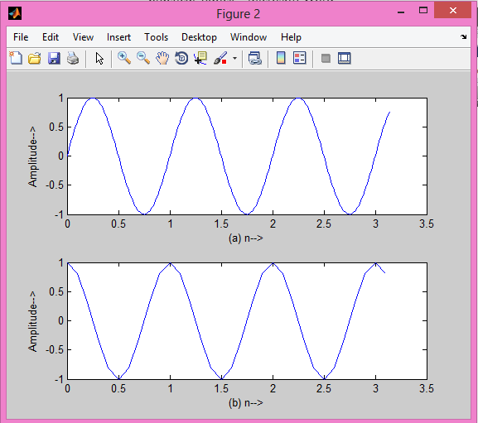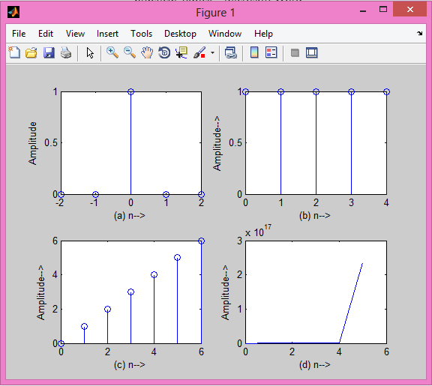
 | GEETA ENGINEERING COLLEGE, NAULTHA, PANIPAT |  |  | LABORATORY MANUAL
EXPERIMENT TITLE: Write a program to plot real part, imaginary part, magnitude and phase spectra of an exponential function. |  |  |  | EXPERIMENT NO:- GEC-LM- EC-311LA -02
ISSUE NO : 001 | ISSUE DATE | 19-12-2013 | REV NO: 003 | REV DATE | 14-01-2021
DEPARTMENT: | ECE | LABORATORY: | DSP | SEMESTER: | 2ND

 | GEETA ENGINEERING COLLEGE, NAULTHA, PANIPAT |  |  | LABORATORY MANUAL
EXPERIMENT TITLE: Study the aliasing effect by using a sinusoidal signal. Show the plots of' continuous time signal, sampled signal and reconstructed signals by using subplot. |  |  |  | EXPERIMENT NO: GEC-LM- EC-311LA -03
ISSUE NO : 001 | ISSUE DATE | 19-12-2013 | REV NO: 003 | REV DATE | 14-01-2021
DEPARTMENT: | ECE | LABORATORY: | DSP | SEMESTER: | 2ND

Aim:- Study the aliasing effect by using a sinusoidal signal. Show the plots of' continuous time signal, sampled signal and reconstructed signals by using subplot.
.

PROCEDURE:-
- Open MATLAB
- Open new M-file
- Type the program
- Save in current directory
- Compile and Run the program
- For the output see command window\ Figure window

PROGRAM:-

Clc;
close all;
clear all;
t=-10:0.01:10;
T=8;
fm=1/T;
x=cos(2*pi*fm*t);
fs1=1.2*fm;
fs2=2*fm;
fs3=8*fm;
n1=-4:1:4;
xn1=cos(2*pi*n1*fm/fs1);
subplot(221)
plot(t,x);
xlabel('time in seconds');
ylabel('x(t)');
title('continous time signal');
subplot(222)
stem(n1,xn1);
hold on;
plot(n1,xn1);
xlabel('n');
ylabel('x(n)');
title('discrete time signal with fs<2fm');

n2=-5:1:5;
xn2=cos(2*pi*n2*fm/fs2);
subplot(223)
stem(n2,xn2);
hold on;
plot(n2,xn2);
xlabel('n');
ylabel('x(n)');
title('discrete time signal with fs=2fm');

n3=-20:1:20;
xn3=cos(2*pi*n3*fm/fs3);
subplot(224)
stem(n3,xn3);
hold on;
plot(n3,xn3);
xlabel('n');
ylabel('x(n)');
title('discrete time signal with fs>2fm');

RESULT:- Thus the program of Aliasing Effect is written and verified

OUTPUT

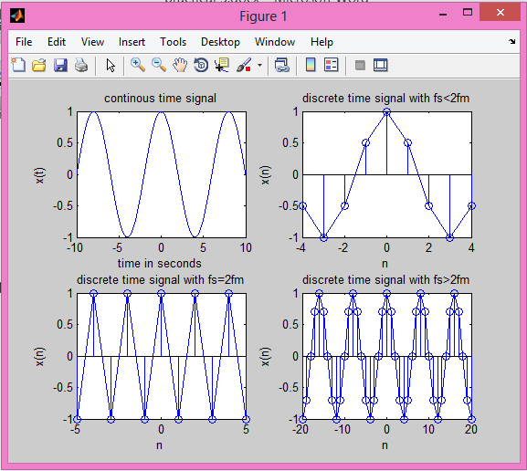

 | GEETA ENGINEERING COLLEGE, NAULTHA, PANIPAT |  |  | LABORATORY MANUAL
EXPERIMENT TITLE: Write a program to compute and plot the convolution of two signals. |  |  |  | EXPERIMENT NO: GEC-LM- EC-311LA -04
ISSUE NO : 001 | ISSUE DATE | 19-12-2013 | REV NO: 003 | REV DATE | 14-01-2021
DEPARTMENT: | ECE | LABORATORY: | DSP | SEMESTER: | 2ND

AIM: Write a program to compute and plot the convolution of two signals.

PROCEDURE:-
- Open MATLAB
- Open new M-file
- Type the program
- Save in current directory
- Compile and Run the program
- For the output see command window\ Figure window

PROGRAM:-

clc;clear all;close all;
x=input('enter 1st seq')
h=input('enter 2nd seq')
y=conv(x,h);
subplot(3,1,1)
stem(x)
xlabel('n')
ylabel('x')
subplot(3,1,2)
stem(h)
xlabel('n')
ylabel('x')
subplot(3,1,3)
stem(y)
xlabel('n')
ylabel('x')
display('The result is'),y;

RESULT:-Thus the program of discrete convolution is written using MATLAB and verified.

enter 1st seq[1 2 3]
x =1 2 3
enter 2nd seq[1 2]
h = 1 2
The result is

OUTPUT:-

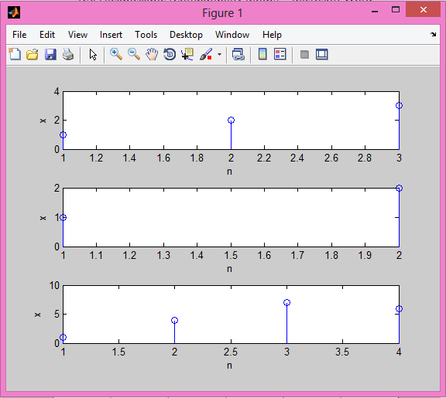

 | GEETA ENGINEERING COLLEGE, NAULTHA, PANIPAT |  |  | LABORATORY MANUAL
EXPERIMENT TITLE: Define a function to compute the Z-transform of a finite length signal. |  |  |  | EXPERIMENT NO: GEC-LM- EC-311LA -05
ISSUE NO : 001 | ISSUE DATE | 19-12-2013 | REV NO: 003 | REV DATE | 14-01-2021
DEPARTMENT: | ECE | LABORATORY: | DSP | SEMESTER: | 2ND

AIM: Define a function to compute the Z-transform of a finite length signal.

PROCEDURE:-
- Open MATLAB
- Open new M-file
- Type the program
- Save in current directory
- Compile and Run the program
- For the output see command window\ Figure window

PROGRAM:-

clc; close all; clear all;
syms 'z';
disp('If you input a finite duration sequence x(n), we will give you its z-transform');
nf=input('Please input the initial value of n = ');
nl=input('Please input the final value of n = ');
x= input('Please input the sequence x(n)= ');
syms 'm';
syms 'y';
f(y,m)=(y*(z^(-m)));
disp('Z-transform of the input sequence is displayed below');
k=1;
for n=nf:1:nl
answer(k)=(f((x(k)),n));
k=k+1;
end
disp(sum(answer));

Example of Output
If you input a finite duration sequence x(n), we will give you its z-transform
Please input the initial value of n = 0
Please input the final value of n = 4
Please input the sequence x(n)= [1 0 3 -1 2]
Z-transform of the input sequence is displayed below

3/z^2 - 1/z^3 + 2/z^4 + 1

 | GEETA ENGINEERING COLLEGE, NAULTHA, PANIPAT |  |  | LABORATORY MANUAL
EXPERIMENT TITLE: - Verify the properties of Discrete Fourier Transform (DFT). |  |  |  | EXPERIMENT NO: GEC-LM- EC-311LA -06
ISSUE NO : 001 | ISSUE DATE | 19-12-2013 | REV NO: 003 | REV DATE | 14-01-2021
DEPARTMENT: | ECE | LABORATORY: | DSP | SEMESTER: | 2ND

AIM:- Verify the properties of Discrete Fourier Transform (DFT).

PROCEDURE:-
- Open MATLAB
- Open new M-file
- Type the program
- Save in current directory
- Compile and Run the program
- For the output see command window\ Figure window

PROGRAM:-

%dft frequency shift property
close all;
clear all;
N=input('how many point dft do you want?');
x1=input('enter the seq');
n2=length(x1);
c=zeros(N);
x1=[x1 zeros(1,N-n2)];
for k=1:N
for n=1:N
w=exp((-2*pi*i*(k-1)*(n-1))/N);
x(n)=w;
end
c(k,:)=x;
end
disp('dft is ');
r=c*x1';
a1=input('enter the amount of shift in frequency domain');
for n=1:N
w=exp((2*pi*i*(n-1)*(a1))/N);
x2(n)=w;
end
r1=x2.*x1;
subplot(221);
stem(abs(r));
grid on;
title('orginal dft magnitude plot');
subplot(222);
stem(angle(r));
grid on;
title('orginal dft angle');
for k=1:N
for n=1:N
w=exp((-2*pi*i*(k-1)*(n-1))/N);
x(n)=w;
end
c(k,:)=x;
end
disp('dft is');
r2=c*r1';
subplot(223);
stem(abs(r2));
grid on;
title('shifted dft magnitude');
subplot(224);
stem(angle(r2));
grid on;
title('shifed dft angle');

RESULT:-Verified the properties of DTFT
how many point dft do you want? 6
enter the seq[1 2 4 6 7 8 ]
dft is
enter the amount of shift in frequency domain 2
dft is

OUTPUT:-

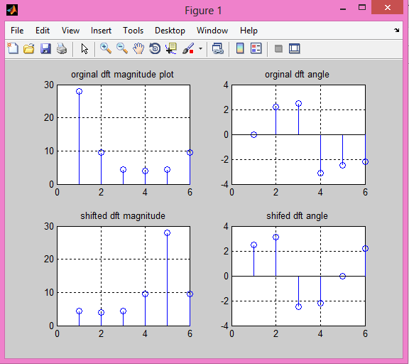

 | GEETA ENGINEERING COLLEGE, NAULTHA, PANIPAT |  |  | LABORATORY MANUAL
EXPERIMENT TITLE: Design of FIR filters by using windowing method. |  |  |  | EXPERIMENT NO: GEC-LM- EC-311LA -07
ISSUE NO : 001 | ISSUE DATE | 19-12-2013 | REV NO: 003 | REV DATE | 14-01-2021
DEPARTMENT: | ECE | LABORATORY: | DSP | SEMESTER: | 2ND

AIM:- Design of FIR filters by using windowing method.

PROCEDURE:-
- Open MATLAB
- Open new M-file
- Type the program
- Save in current directory
- Compile and Run the program
- For the output see command window\ Figure window

PROGRAM:-

clc;
close all;
clear all;
format long;
rp=input('enter the passband ripple');
rs=input('enter the stopband ripple');
fp=input('enter the passband frequency');
fs=input('enter the stopband frequency');
f=input('enter the sampling frequency');
beta=input('enter the beta value');
wp=2*(fp/f);
ws=2*(fs/f);
num=-20*log10(sqrt(rp*rs))-13;
dem=14.6*(fs-fp)/f;
n=ceil(num/dem);
n1=n+1;
if(rem(n,2)~=0)
n1=n;
n=n-1;
end;
y=kaiser(n1,beta);
%Lowpass filter
b=fir1(n,wp,y);
[h,o]=freqz(b,1,256);
m=20*log10(abs(h));
subplot(2,1,1);
plot(o/pi,m);
ylabel('gain in db---->');
xlabel('Normalised frequency---->');
title('FIR filter using Kaiser window of LPF ----');
grid on;

%Highpass filter
b=fir1(n,wp,'high',y);
[h,o]=freqz(b,1,256);
m=20*log10(abs(h));subplot(2,1,2);
plot(o/pi,m);
ylabel('gain in db---->');
xlabel('Normalised frequency---->');
title('FIR filter using Kaiser window of HPF ----');
grid on;

RESULTS:- Thus the MATLAB program for FIR LP\HP using Kaiser Window Techniques was executed.

INPUT:-
enter the pass band ripple 0.02
enter the stop band ripple 0.01
enter the pass band frequency 1000
enter the stop band frequency 1500
enter the sampling frequency 10000
enter the beta value 5.8

OUTPUT:

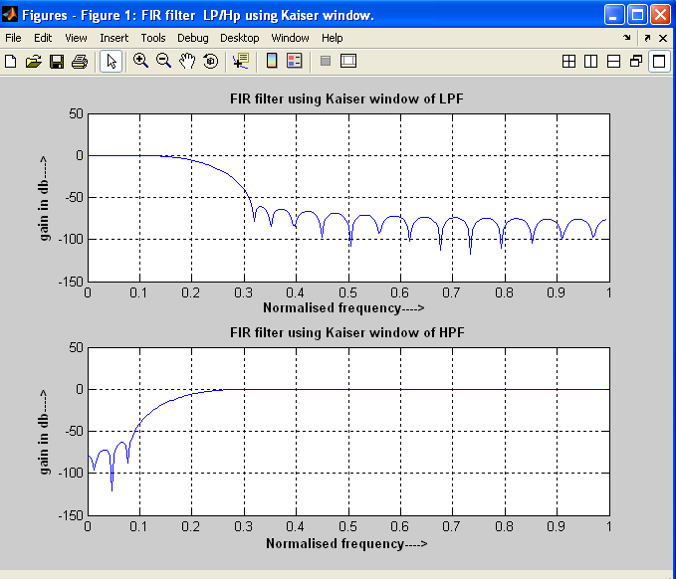

 | GEETA ENGINEERING COLLEGE, NAULTHA, PANIPAT |  |  | LABORATORY MANUAL
EXPERIMENT TITLE: Design of equiripple FIR filter. |  |  |  | EXPERIMENT NO: GEC-LM- EC-311LA -08
ISSUE NO : 001 | ISSUE DATE | 19-12-2013 | REV NO: 003 | REV DATE | 14-07-2016
DEPARTMENT: | ECE | LABORATORY: | DSP | SEMESTER: | 2ND

 | GEETA ENGINEERING COLLEGE, NAULTHA, PANIPAT |  |  | LABORATORY MANUAL
EXPERIMENT TITLE: Study of magnitude and phase response of Butterworth, Chebyshev and Elliptic filters. |  |  |  | EXPERIMENT NO: GEC-LM- EC-311LA -09
ISSUE NO : 001 | ISSUE DATE | 19-12-2013 | REV NO: 003 | REV DATE | 14-01-2021
DEPARTMENT: | ECE | LABORATORY: | DSP | SEMESTER: | 2ND

 | GEETA ENGINEERING COLLEGE, NAULTHA, PANIPAT |  |  | LABORATORY MANUAL
EXPERIMENT TITLE: Design of IIR filters by using different analog filter approximation method. |  |  |  | EXPERIMENT NO: GEC-LM- EC-311LA -10
ISSUE NO : 001 | ISSUE DATE | 19-12-2013 | REV NO:003 | REV DATE | 14-01-2021
DEPARTMENT: | ECE | LABORATORY: | DSP | SEMESTER: | 2ND

